**Design a normalized table for the below pages**

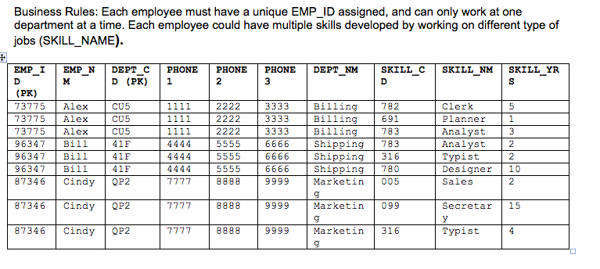

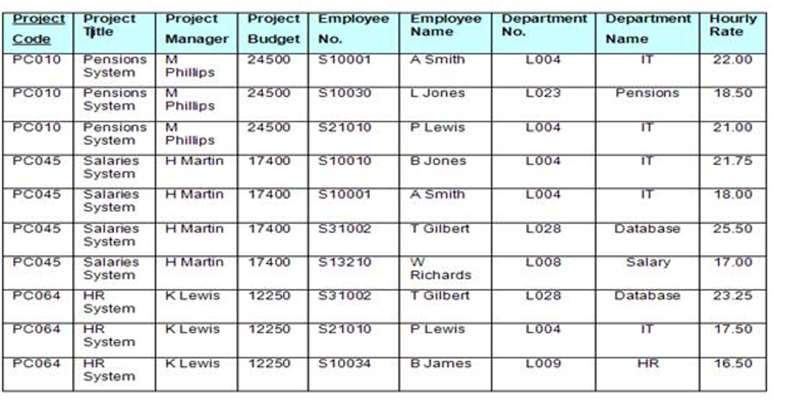

**Write the SQL query for the below**

1. Create a table employee (First Name, Last Name, Title, Age, Salary). Determine the data type as required.
2. Insert Records as follows and add 5 more employees of your choice.

* Anika James, Secretary, 55, 99500.00
* Peter Johnson, Programmer, 32, 45300.00
* Paul Ericsson, Programmer II, 45, 75020.00
* Ashwini Vasanth, Assistant Secretary, 28, 19500.00

1. Enter select statements to:

* Select all columns for everyone with a salary below 50000.
* Select Full Name (FirstName, Last Name) for everyone that's above 30 years old.
* Select first name, last name, and salary for anyone with "secretary" in their title.
* Select all columns for everyone whose last name contains "son".
* Select everyone whose first name equals "Brian".
* Select all columns for everyone over 50 years old.

1. After each update, issue a select statement to verify your changes.

* Ashwini Vasanth just got married to Bob Williams. She has requested that her last name be updated to Ashwini-Williams.
* Paul Ericsson’s birthday is today, add 1 to his age.
* All secretaries are now called "Admin Assistant". Update all titles accordingly.
* Everyone that's making under 40000 are to receive a 5300 a year raise.
* Everyone that's making over 75000 are to receive a 4500 a year raise.
* All "Programmer II" titles are now promoted to "Programmer III".
* All "Programmer" titles are now promoted to "Programmer II".

1. Ashwini Williams just quit, remove her record from the table.
2. Remove all employees who are making over 70000 as salary.

**Reference:**

<https://www.youtube.com/watch?v=jgUeOjImOOw>

